Project Development Phase
Model Performance Test

Date | 10 February 2026
Team ID | LTVIP2026TMIDS42870
Project Name | electric motor temperature prediction using machine learning
Maximum Marks | 10 Marks

Model Performance Testing:
Project team shall fill the following information in model performance testing template.
S.No. | Parameter | Values | Screenshot
 | Metrics | Regression Model:  MAE - , MSE - , RMSE - , R2 score -  Classification Model:  Confusion Matrix - , Accuray Score- & Classification Report - | 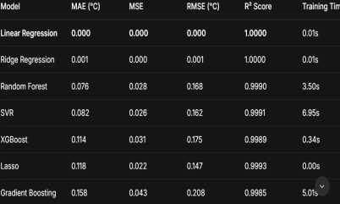
 | Tune the Model | Hyperparameter Tuning -  Validation Method - | 